**Insights From Exploratory Data Analysis of MtCars Dataset**

**Univariate Analysis of Target Variable (Miles Per Gallon)**

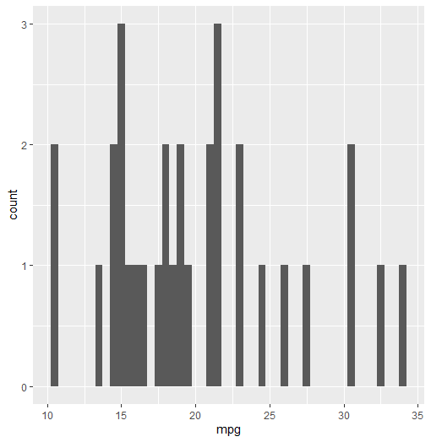

**Summary Statistics**

> summary(mtcars$mpg)

Min. 1st Qu. Median Mean 3rd Qu. Max.

10.40 15.43 19.20 20.09 22.80 33.90

The Miles Per Gallon variable is almost normally distributed as the mean is only slightly greater than the median.

1. **Fuel Economy**: V-shaped engines in this data set consume more fuel than straight shaped. There is an outlier value for the v-shaped engine values where an observation has an unusually high MPG implying that it uses less fuel than the regular v-shaped engine, this might be a data error, or perhaps an advanced technology like an hybrid engine.

Automatic transmission vehicles are also less fuel economical than manual.

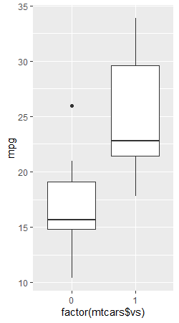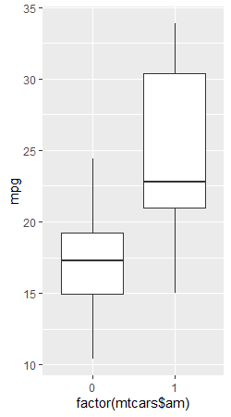

4 gear systems consume the most fuel, followed by 5 gears and 3 gears.

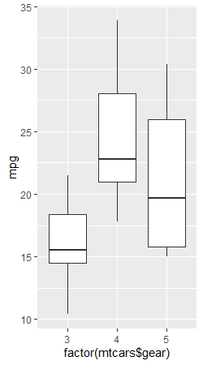

1. **Engine Power and Speed.**

V-shaped engines have higher horse power ratings and complete a quarter mile in way less time than it takes a straight shaped engine

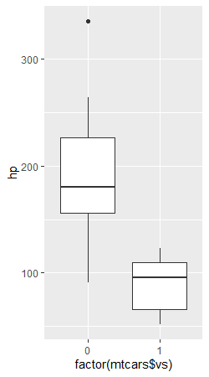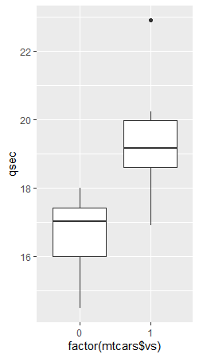

Automatic transmission vehicles also appear to have higher horse power ratings than manual. Manual transmission vehicles however seem slightly faster than automatic transmission There seems to be an anomaly in this part of the data because higher horsepower should result in faster speeds which is not the case here.

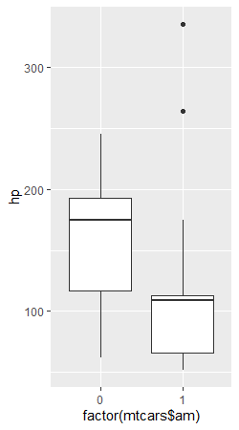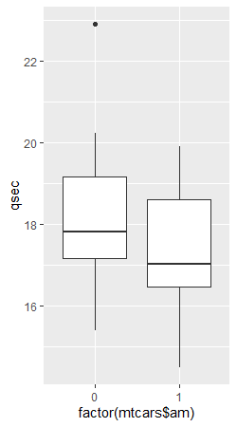

1. Weight and Axle Ratio: There’s a higher number of straight shaped engines that have higher rear axle ratio than v-shaped engines, meaning most of the straight shaped engines are rear wheel drives, with outliers in both directions. Also, V-shaped engine cars are heavier than straight shaped.

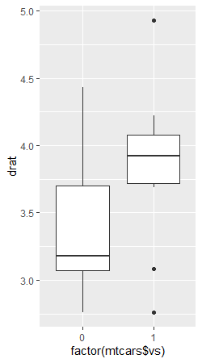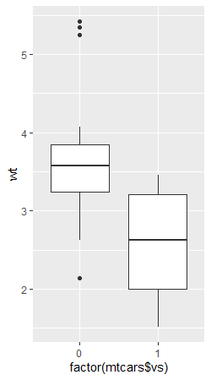

There’s a clearer distinction in rear axle ratio based on transmission as more manual transmission vehicles are in rear axle drive mode while the automatic transmission vehicles have less rear axle ratio. Automatic transmission vehicles also weigh far more than the manual transmission

